Simple 2d Cel Shading on top of Simple Characters similar to the rogue souls games

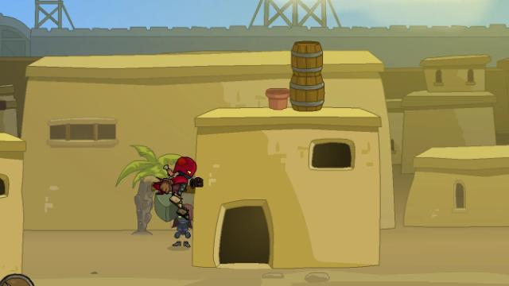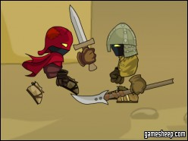

<http://veedif.com/files/thumbs/rogue-soul-2.jpg>

<http://www.gamesheep.com/game/rogue-soul/thumb_248x186.jpg>